2.0μm emission investigated in Ho³⁺/Yb³⁺ codoped germanate-tellurite glasses

Yapei Peng,^{1, 2} Junjie Zhang,³and Long Zhang¹ *
¹Key Laboratory of Materials for High Power Lasers, Shanghai Institute of Optics and Fine Mechanics, Chinese Academy of Sciences, Shanghai 201800, China
²University of Chinese Academy of Sciences, Beijing 100039, China
³China Jiliang University, Hangzhou 310018, China

ABSTRACT
2.0μm emission property of a new germanate-tellurite glass with Ho³⁺/Yb³⁺ codoping is synthesized and analyzed. Efficient 2.0μm emission of Ho³⁺ ions sensitized by Yb³⁺ ions from the host glass was observed under 980nm pumping. Based on the measured absorption spectra, the Judd-Ofelt parameters were calculated and discussed. Strong emission around 2.0μm is observed and the sensitization of Ho³⁺ is realized by codoping of Yb³⁺ ions. The radiative transition probability and radiative lifetime of Ho³⁺:⁵I₇→⁵I₈ in GTLaF-1 are 88.22s⁻¹ and 11.33ms, respectively. The maximum emission cross section of Ho³⁺:⁵I₈→⁵I₇ transition is 4.36×10⁻²¹ cm² around 2.0μm. The energy transfer efficiency and energy transfer rate are calculated to be 81.2% and 6506.55s⁻¹ in GT glass. The energy transfer efficiency is calculated and fitted the decay signals. The good spectroscopic properties suggest that Ho³⁺/Yb³⁺ codoped germanate-tellurite glass may become an attractive host for developing solid state lasers operating in the mid-infrared.

Keyword: Rare-earth ions, germanate-tellurite glass, 2μm laser

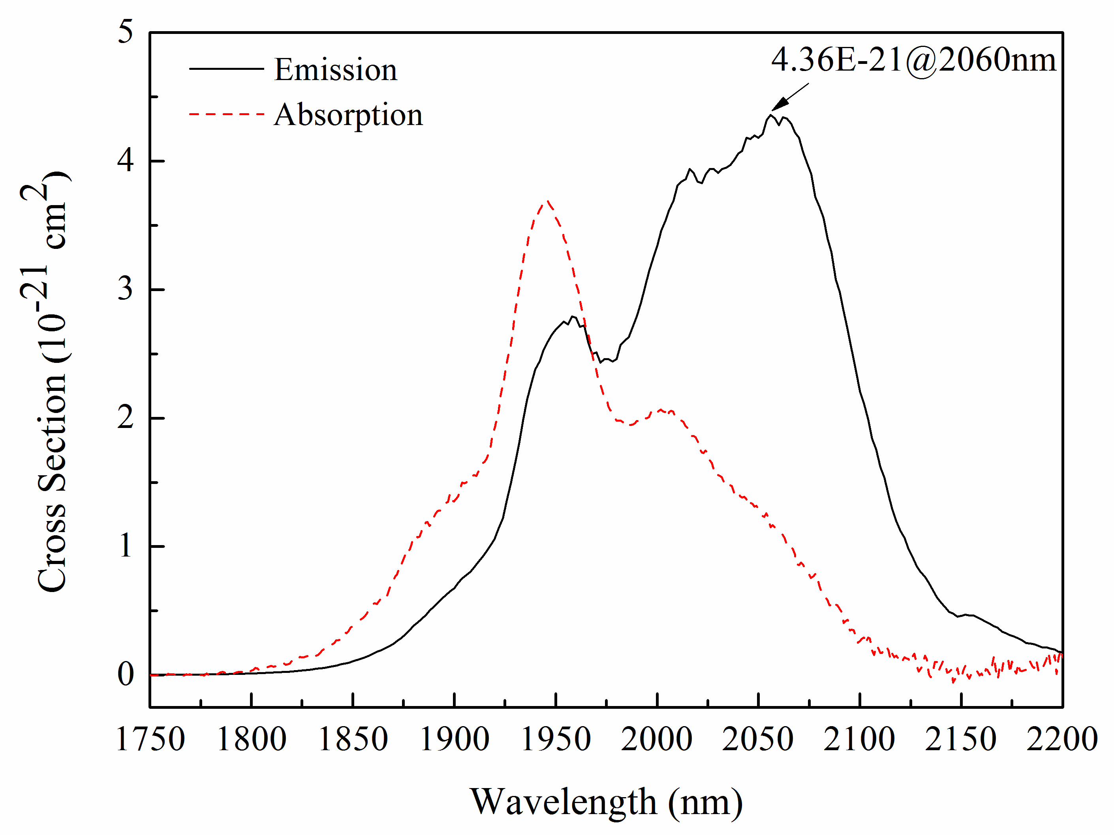
Fig. 1 Absorption and emission cross section of Ho³⁺:⁵I₈→⁵I₇ in GTLaF-1 glass.

* Corresponding author: lzhang@siom.ac.cn

